

Estimation of State-Level Causal Effects of Rental Prices on Home Values in the United States Using Causal Machine Learning

Far Eastern University - Manila

Machine Learning

Lansangan, Romand

December 2025
Chapter 1: Introduction 4
1.1 Project Overview and Context 4
1.2 Problem Statement 4
1.2.1 Simultaneity 4
1.2.2 Reverse Causality 5
1.3.3 Omitted Variable Bias 5
1.2.4 Heterogeneous Effects 5
1.2.5 Traditional Machine Learning is not meant for Causation 5
1.3 Proposed Solution 5
1.3.1 Causal Machine Learning 5
1.3.2 Double Machine Learning (DoubleML): 6
1.3.3 Causal Forest: 6
1.4 Project Goal and Objectives 6
1.5 Significance of the Study 7
1.5.1 Policymakers and Housing Agencies 7
1.5.2 Real Estate Investors and Financial Institutions. 8
1.5.3 Central Banks and Macroeconomic Analysts. 8
1.5.4 Urban Planners and Local Governments. 8
1.5.5 Academic Researchers. 8
Chapter 2: Review of Related Literature 9
2.1 Theoretical Foundations 9
2.1.1 Gordon Growth Model 9
2.1.2 Market Elasticity 10
2.2.3 Potential Outcomes Framework 10
2.2 Domain-Specific Literature Review 10
2.3 Review of Methodological Approaches 11
2.4 Research Gap and Project Contribution 12
Chapter 3: Methodology 13
3.1 Project Design Overview 13
3.1.1 Identification Strategy 13
3.1.2 Causal Graph 13
3.1.3 Causal Assumptions 14
3.2 Data Sources 14
3.2 Data Cleaning and Preprocessing 17
3.2.1 Spatial Aggregation 17
3.2.2 Temporal Alignment 17
3.2.3 Handling Missing Values 18
3.2.4 Multicollinearity Reduction 18
3.2.5 Feature Engineering: Growth Rate Transformation 20
3.2.6 Lag Structure for Causal Identification 21
3.2.7 Outliers 22
3.2.8 Encoding for Machine Learning 23
3.2.8 Final Analytical Dataset 23
3.3 Model Selection and Rationale 24
3.4 Experimental Setup 25
3.4.1 For Average Treatment Effect (ATE) Estimation: 25
Chapter 4: Empirical Results and Model Analysis 27
4.1 Computational Environment and Experimental Implementation 27
4.2 Baseline Models 27
4.2.1 Hyperparameter Tuning 27
4.2 Primary Model Results: Average Treatment Effect 28
4.3.1 Sensitivity Analysis and Robustness Checks 30
4.3 Primary Model Results: Conditional Average Treatment Effect 31
4.4.1 Interpretation 33
4.4 Dashboard 36
4.5 Discussion of Results 36
Chapter 5: Conclusion and Future Work 39
5.1 Summary of Findings 39
5.2 Project Contribution and Significance 39
5.2 Project Contribution and Significance 39
5.3 Recommendations for Future Work 40
REFERENCES 41
Appendix A: Code Snippets 44
A.1 Data Sources and Initial Processing 44
B.1 Bureau of Labor Statistics (BLS) Employment Data 44
A.2 FRED 30-Year Mortgage Rate 44
A.3 FRED Average Hourly Earnings by State 45
A.4 FRED Building Permits by State 45
A.5 Bureau of Economic Analysis (BEA) Regional Data 45
A.2 Data Paths Object 46
A.3 Save Model and Resources for Dashboard 48
Appendix B: Data Dictionary 51
Appendix C: Supplemental Figures/Tables 53

Abstract
The relationship between rental prices and home values has long been observed in U.S. housing markets and although they tend to move together, the concrete causation of one to the other remains unexplored. This study attempts to quantify the causality of rental price growth on future home price appreciation across U.S. states by application of the relatively new field/framework of Causal Machine Learning: particularly, Double Machine Learning (DoubleML) and Causal Forest. Using a panel dataset of 2,300 state-month observation from 2020 to 2024 from various sources (Zillow housing indices, Bureau of Economic Analysis economic indicators, Federal Reserve financial data, and Bureau of Labor Statistics employment measures), this research implements Double ML to estimate for Average Treatment Effect (ATE) and Causal Forest for heterogeneous treatment effect analysis or Conditional Treatment Effect (CATE). A temporal lag structure (treatment at time t, outcome at t+12 months, confounders at t-12 months) combined with state and time fixed effects enables causal identification from observational data. The result indicates statistically significant ATE of 0.0514 (p < 0.001, 95% CI: [0.026, 0.085]), implying that a 1 percentage point increase in annual rent growth causes approximately 0.05 percentage points higher home price growth one year later. On the other hand, the Causal Forest analysis reveals that heterogeneity does exists where housing supply elasticity emerges as the dominant effect modifier (32.5% importance), with supply-constrained (inelastic) markets exhibiting 2.4 times stronger rent-to-price transmission than elastic markets (CATE: 0.087 vs. 0.037). These findings validate theoretical predictions from Saiz (2010) and offer actionable insights for geographically targeted housing policy interventions and investment opportunities.

Chapter 1: Introduction

1.1 Project Overview and Context
The United States housing market is experiencing an unprecedented affordability crisis. According to Harvard Joint Center for Housing Studies (2025), from 2016, home prices increased by 60 percent with the median price for single-family homes reaching a record of $412,500 in 2024–which is approximately five times the median household income. This historically terrible price-to-income ratio (5:1) significantly exceeds the more usual sustainable benchmark of 3:1. This in turn raises substantial barriers to homeownership of millions of Americans. The National Association of Home Builders (2024) estimates that nearly half of U.S. households (49%) cannot afford a $250,000 home under conventional standards or through mortgage/loans from banks. The rental market too experienced substantial pressure. According to the report of the Harvard Joint Center for Housing Studies, cost-burdenced renters (those who are spending more than 30 percent of their income on housing) reached a record high 22.6 million households in 2023, almost 50 percent of all renters. Both ownership and rental markets raise fundamental questions about the relationship between these two segments: specifically, to what extent do changes in rental prices cause subsequent changes in home prices, as opposed to both merely responding to common underlying economic and political factors?

1.2 Problem Statement
Intuitively speaking, rental price and house price move together but this does not tell the whole story. When the price of a house is higher, if the owner wants to rent the house, they will do so at a higher price too. This is the exact definition of correlation. However, as the ever ubiquitous phrase goes, correlation does not mean causation. The present-value framework for housing prices (Campbell & Shiller, 1988; Campbell et al., 2009) suggests that home prices should theoretically reflected discounted present value of future rental income streams. However, empirical analysis about the causality of rental price to the home price have yet to be explored due to the following reasons:

1.2.1 Simultaneity
Both rent and prices respond to similar and common demand shocks like income growth, population migration, employment changes, etc. This in turn creates a misleading correlation that may be mistaken to reflect a causal transmission from rent to price.

1.2.2 Reverse Causality
Expectation of higher future prices may cause the landlords to raise the current rents. This is a reversal of the presumed causal direction.

1.3.3 Omitted Variable Bias
Just like in demand shocks, there are also some factors that affects both the rents and the price of a house like neighborhood amenity improvements or regulatory changes.

1.2.4 Heterogeneous Effects
The causal effect may not be uniformed to all types of houses. The rent-to-price transmission may differ, for example, in California as it was in Texas. Or condo units are less prone to changes in price no matter how high the rents may be. This is called heterogeneity of causal effects, which implies that aggregated estimates may have the possibility of obscuring important variations in causal effects.

1.2.5 Traditional Machine Learning is not meant for Causation
Although traditional econometrics and machine learning model, like vector autoregression and error-correction models (Gallin, 2008), can be used to provide valuable insights into their relationship, they struggled to isolate causal effects–especially in the presence of high-dimensional confounders (variables that affects both the rent and the house price) and heterogenous treatment effects. Traditional machine learning exploits correlation between the features (W) and the output (Y) but does not necessarily care about whether some features caused the output to be of certain value and as to what extent. All they care about is they move together and what’s the pattern in their movement. However, despite their antithetic original purpose, these machine learning models can be extended to calculate for causal effects, this is called Causal ML.

1.3 Proposed Solution

1.3.1 Causal Machine Learning
Like in any Causal Analysis, the idea of Causal Machine Learning is to control the effects of confounding variables (W) to both treatment (T) and outcome (Y) to estimate for causal effect. What makes the Causal Machine Learning framework different is that it uses the modern and established Machine Learning algorithms to accomplish this objective. This research employs a Causal Machine Learning framework to implement and combine two complementary methodologies to address the rent-to-price causality question.

1.3.2 Double Machine Learning (DoubleML):
By following Chernozhukov et al. (2018), this research implements a partial linear regression by utilizing any flexible machine learning methods to estimate the causal effect. The specifics will be talked more about in the Chapter 3 but ideally, through application of DoubleML, the research will be able to estimate the Average Treatment Effect (ATE) even with high-dimensional confounders.

1.3.3 Causal Forest:
Building on Wager and Athey (2018), this research estimates heterogeneous treatment effects using an honest random forest approach that partitions the covariate space to identify subpopulations with systematically different causal effects. This method is particularly valuable for discovering whether rent-to-price transmission varies with housing supply elasticity—a relationship predicted by urban economic theory (Saiz, 2010) but not previously tested in a causal inference framework.
The expected output includes: (1) a point estimate of the average causal effect of a 1 percentage point increase in rent growth on home prices 12 months later; (2) state-level conditional average treatment effects revealing geographic heterogeneity; (3) feature importance rankings identifying the primary drivers of effect heterogeneity; and (4) an interactive visualization tool for exploring results. These outputs directly address the needs of policymakers designing housing interventions, investors seeking leading indicators, and researchers studying housing market dynamics.

1.4 Project Goal and Objectives
To quantify the causal effect of rental price changes on future home prices across U.S. states, controlling for observable confounders, and to identify systematic heterogeneity in this causal relationship that can inform targeted housing policy interventions and investment strategies.
The following SMART (Specific, Measurable, Achievable, Relevant, Time-bound) objectives guide this research:
1. Construct a comprehensive state-level panel dataset integrating Zillow housing indices (ZORI, ZHVI, SAIZ), Bureau of Economic Analysis economic indicators, Federal Reserve financial data, and Bureau of Labor Statistics employment measures, with appropriate temporal alignment and lag structure, by the project midpoint.
2. Estimate the Average Treatment Effect (ATE) of rent growth on 12-month-ahead home prices using Double Machine Learning, achieving coefficient estimates with standard errors suitable for statistical inference at the 95% confidence level.
3. Estimate Conditional Average Treatment Effects (CATE) using Causal Forest methodology, identifying at least three statistically significant effect modifiers (e.g., housing supply elasticity, income level, population growth) that explain heterogeneity in rent-to-price transmission.
4. Validate causal estimates through placebo tests (demonstrating that current rent does not predict past prices), sensitivity analysis for unobserved confounding, and theoretical consistency checks against Saiz (2010) housing supply elasticity predictions.
5. Develop an interactive prototype dashboard enabling users to explore state-level CATE estimates and simulate treatment effects under varying market conditions, demonstrating practical applicability of the research findings.

1.5 Significance of the Study
This research holds relevance for multiple stakeholders operating within and around U.S. housing markets:

1.5.1 Policymakers and Housing Agencies
Federal, state, and local policymakers designing housing interventions like including rent control measures, zoning reforms, and housing subsidies all will benefit from learning more about how rental market dynamics transmit to ownership markets. If it is indeed the case that rent causally drive home price to some extent, policies targeting rental affordability may yield benefits for homeownership accessibility. Conversely however, if the correlation is driven by demand factors, interventions must address those drivers directly. The heterogeneous treatment effects inference by Causal Forest can also be used to design a policy that is geographically targeted–where the policies targeting rent can have the greatest impact.

1.5.2 Real Estate Investors and Financial Institutions.
Institutional investors, real estate investment trusts (REITs), and mortgage lenders benefit from understanding whether rental price trends serve as leading indicators for home price movements. If a causal relationship exists, rent trends could signal for some actionable insights for portfolio allocation, market timing, and risk assessment. The state-level CATE estimates also offer geographic specificity relevant to regionally diversify their investment strategies.

1.5.3 Central Banks and Macroeconomic Analysts.
Housing constitutes a major part in procurement of monetary policy. For example, shelter costs are costs like rent, mortgage payments, utilities (like electricity and gas), property taxes, and insurance, shaped some of the more prominent welfare programs a government can implement. Understanding how rent shocks propagate to home prices ought to inform monetary policy modification/calibration to build a smarter and data-driven regulation. The research is particularly timely given ongoing debates about the role of housing in post-pandemic inflation dynamics and the effectiveness of interest rate policy in cooling housing markets constrained by the lock-in effect. The Federal Housing Finance Agency (Batzer et al., 2024) documents that the mortgage rate "lock-in" effect has prevented approximately 1.7 million home sales between 2022 and 2024

1.5.4 Urban Planners and Local Governments.
Zoning and permitting decisions directly affect housing supply elasticity, which this research identifies as a key moderator of rent-to-price transmission. Planners can use the findings to anticipate how local supply constraints amplify or dampen the price effects of rental market shocks, informing land use policy and infrastructure investment decisions.

1.5.5 Academic Researchers.
This study contributes to the housing economics literature by applying causal machine learning methods that are previously concentrated in labor economics and program evaluation to a classic question in urban economics. The methodological framework demonstrates how Double Machine Learning and Causal Forest can be deployed for causal inference with observational panel data, offering a template for future research on housing market dynamics.

Chapter 2: Review of Related Literature

2.1 Theoretical Foundations
This study is based on three theoretical foundations: (a) Present-Value framework and (b) Gordon Growth Model, both models how much people are willing to pay given expected rent growth and (b) Potential Outcomes Framework which is the foundation to all causal inferences and analysis.

2.1.1 Gordon Growth Model
The theoretical basis for this research rests on the present-value framework for asset pricing, which is further extended by the use of Gordon Growth Model. Campbell and Shiller (1988) established that the expected price of an asset (house, machinery, vehicle, etc.) is equal to the discounted future cash flows it brings.
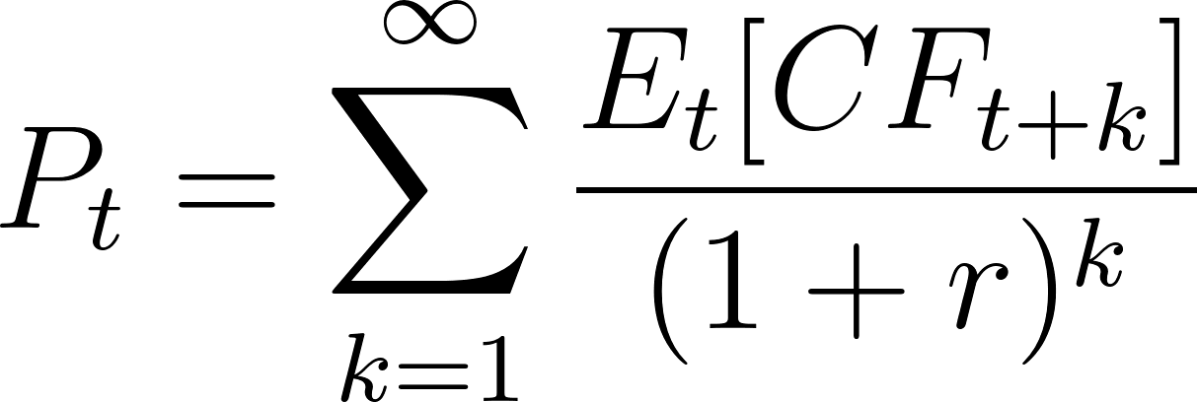
This implies that home prices theoretically reflect the discounted present value of future rental income streams. Campbell et al. (2009) extended this framework by using Gordon Growth Model to explain that people are willing to pay higher price for a house based on either (a) they require lower rates or (b) they expect a higher growth in rent in the future–or both.
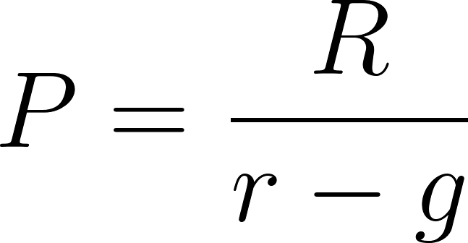
Where:
-  is the price that people are willing to pay
-  is the expected returns
-  is a constant rental price growth in the future.
According to this model, when rent rises so does price because buyers are rationally updating the expectations about future rents (higher g).

2.1.2 Market Elasticity
Saiz (2010) provides the theoretical basis for understanding geographic heterogeneity in housing market dynamics. Housing supply elasticity measures how responsive new construction is to price changes, or the percentage change in housing stock per one percent change in price.
This elasticity varies dramatically across U.S. markets due to geographic constraints (water bodies, steep terrain) and regulatory restrictions (zoning, permits). Supply-constrained markets like San Francisco (ε ≈ 0.7) cannot easily expand housing stock, while elastic markets like Houston (ε ≈ 2.5) can absorb demand shocks through new construction.
The implication for rent-to-price transmission is direct: in inelastic markets, demand shocks manifest primarily as price increases since supply cannot respond. In elastic markets, new construction absorbs demand pressure, dampening price effects. This theoretical prediction motivates the Causal Forest analysis. If Saiz's framework holds, supply-constrained states should exhibit stronger rent-to-price causal effects.

2.2.3 Potential Outcomes Framework
The Potential Outcomes Framework, foundational to causal inference, provides the statistical basis for this study. Rubin (1974) formalized causal effects as comparisons between potential outcomes (home price in the future) under treatment (rent price now) and control conditions (confounders, or variables that affect both rent and house’s price). Key identification assumptions include unconfoundedness (all confounders are defined), positivity (all units are represented well among treatments), and SUTVA (Stable Unit Treatment Value Assumption; One house's rent doesn't affect another house's price; and there's only one version of "high rent."). Pearl's (2009) structural causal model framework complements this approach by distinguishing between association, intervention, and counterfactual reasoning—the three rungs of the causal hierarchy.

2.2 Domain-Specific Literature Review
Research on housing market dynamics has extensively documented the relationship between rents and home prices. Gallin (2008) examined the long-run equilibrium relationship between house prices and rents using error-correction models. They found evidence that although rents and prices tend to deviate for some time, both move together long-term–with prices being more volatile while rents follow at a much slower phase.
Saiz (2010) also documented a geographic variation in housing supply elasticity across U.S. metropolitan areas. His research showed that areas with geographic constraints (steep terrain, water bodies) exhibit lower supply elasticity which makes them more susceptible to greater price as a response to demand shocks. This heterogeneity in supply suggests that the rent-to-price transmission may vary across locations–a hypothesis which could be tested through Causal Forest methodology.
Batzer et al. (2024) documented an unprecedented “lock-in effect” affecting approximately 1.7 million home sales between 2022 to 2024. Following the 2022 interest rate increase, homeowners with low-rate mortgages (sub-4%) become more reluctant to sell due to sudden increase to around 7% in 2022 in mortgage rate (largely imposed by the treasury). This strange phenomenon causes low supply but highly demanded resulting in prices remaining high–making the real-estate market stagnant. This phenomenon has altered traditional housing market dynamics and provides context for understanding contemporary rent-price relationships.

2.3 Review of Methodological Approaches
Traditional econometric approaches to housing market analysis have relied on vector autoregression (VAR), error-correction models, and other machine learning models to capture the dynamic relationship and long-run equilibria of rent and prices. But all fail to isolate causal effects in the presence of high-dimensional confounders.
Double/Debiased Machine Learning (DoubleML) introduced by Chernozhukov et al. (2018) provides a valid causal inference while leveraging flexible ML methods for accurate parameter estimation. Their approach utilizes orthogonalization (making the treatment and outcome free from the effects of confounders) and cross-fitting which eliminates regularization bias which is present in traditional machine learning methods. This methodology is particularly suited for settings with high-dimensional confounders common in housing market analysis.
Wager and Athey (2018) developed Causal Forest, an adaptation of random forests for heterogeneous treatment effect estimation. The method uses "honest" estimation by splitting samples between tree construction and effect estimation (usually 50:50 split) to achieve valid confidence intervals. Causal Forest automatically discovers effect heterogeneity by partitioning the covariate space, identifying subpopulations with systematically different treatment effects. This capability is essential for understanding how rent-to-price transmission varies across different market conditions.

2.4 Research Gap and Project Contribution
Despite extensive research on housing market dynamics, significant gaps remain.
First, the existing studies are composed mainly of documents for correlational relationship between price and rent rather than their causal effects. As was mentioned in Chapter 1, the simultaneity of rent and price determination, combined with omitted variable bias from unobserved local factors, has prevented clean causal identification.
Second, no research has systematically examined heterogeneity in the rent-to-price causal effect before–not through the use of modern machine learning methods capable of discovering effect modifiers in high-dimensional settings.
This research contributes to the literature by:
- Applying Double Machine Learning to estimate the average causal effect of rent growth on future home prices, properly controlling for high-dimensional confounders through orthogonalization;
- Using Causal Forest to discover heterogeneous treatment effects across states and market conditions;
- Testing theoretical predictions about supply elasticity as an effect modifier; and
- Providing actionable estimates for policymakers, investors, and researchers through an interactive visualization tool.

Chapter 3: Methodology

3.1 Project Design Overview
This research employs an observational causal inference design using panel data across U.S. states. The objective is to estimate valid causal parameters or the effect of rental price changes on future home values rather than to maximize predictive accuracy–which is the objective of traditional machine learning methods.

3.1.1 Identification Strategy
Treatment (rent) is measured at time t while outcome (home price) is measured at t+12. This is to give time for the effect of rent price, if there were any, to take into effect.
Annual growth was also calculated for the variables with temporal dependence to avoid correlation caused by trend.
State fixed effects absorb time-invariant heterogeneity; time fixed effects absorb nationwide shocks (e.g., Federal Reserve policy, macroeconomic cycles).
Observable confounders spanning demand factors (income, population, employment), supply factors (building permits, Saiz elasticity), price levels (regional price parities), and financing conditions (mortgage rates) are included to satisfy unconfoundedness.

3.1.2 Causal Graph
The assumed causal structure is formalized in the following Directed Acyclic Graph (DAG):
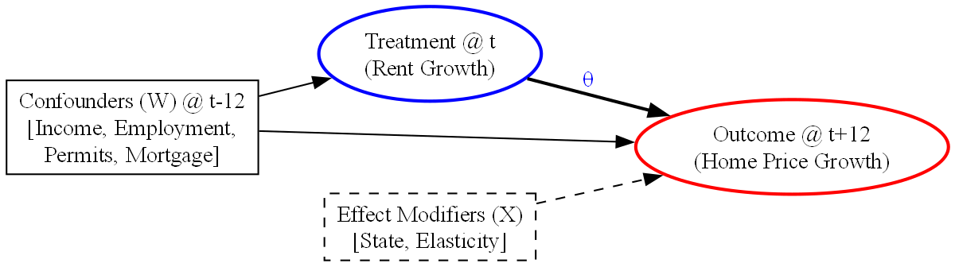

The graph encodes the following assumptions:
- Confounders (W) affect both rent and price and must be controlled
- Rent causally affects future price—the effect we estimate (θ)
- Effect modifiers (X) do not confound the rent→price relationship but moderate its magnitude:
  - State captures geographic, regulatory, and cultural factors affecting transmission strength
  - Saiz Elasticity captures supply constraints (low elasticity → stronger effect).
  - Income Level captures market purchasing power dynamics
- Unobserved confounders are assumed sufficiently blocked by W, state fixed effects, and time fixed effects
Note: State operates at two levels: as a fixed effect absorbing permanent differences (in W), and as an effect modifier allowing CATE to vary geographically (in X).

3.1.3 Causal Assumptions
The key identifying assumption is that, conditional on observed confounders W, state fixed effects, and time fixed effects, remaining variation in rent is uncorrelated with unobserved determinants of future prices. This assumption is assessed through placebo tests and sensitivity analysis.

3.2 Data Sources
The original set of dataset used can be found on appendix (Table B.1) but was later trimmed down to the following due to multicollinearity concerns. By the end, the following are the dataset used:

Dataset | Source | Description | Temporal Scale | Spatial Scale | Key Variables Derrived
Zillow Observed Rent Index (ZORI) | Zillow Research (public) | Smoothed, seasonally adjusted rental price index for single-family and condo rentals | Monthly (2015–2025) | Metro → aggregated to State | RentalPrice, RentGrowth
Zillow Home Value Index (ZHVI) | Zillow Research (public) | Smoothed, seasonally adjusted typical home value for middle-tier (33rd–67th percentile) single-family and condo | Monthly (2000–2025) | State | HomePrice, HomePriceGrowth
Zillow Inventory | Zillow Research (public) | Count of unique listings active during a given month | Monthly (2018–2025) | Metro → aggregated to State | Inventory, InventoryGrowth
BLS Employment Data | Bureau of Labor Statistics (public) | State-level labor market statistics from Current Population Survey | Monthly (2000–2024) | State | unemployment rate, employment-population ratio
FRED Hourly Earnings | Federal Reserve Economic Data (public) | Average hourly earnings of production and nonsupervisory employees | Monthly (2007–2025) | State | Avg. Monthly Wage per Hours, WageGrowth
FRED Building Permits | Federal Reserve Economic Data (public) | New privately-owned housing units authorized by building permits | Monthly (2000–2025) | State | BuildingPermits, PermitsGrowth
FRED 30-Year Mortgage Rate | Federal Reserve Economic Data (public) | Weekly average 30-year fixed-rate mortgage (aggregated to monthly) | Weekly → Monthly (1971–2025) | National | MORTGAGE30US, MortgageChange
Saiz Housing Supply Elasticity | Saiz (2010) via academic repository | Geographic determinants of housing supply elasticity based on land constraints and topography | Static (time-invariant) | MSA → aggregated to State | elasticity
Table 3.1: Summary of Data Sources Used in the Analysis

3.2 Data Cleaning and Preprocessing

3.2.1 Spatial Aggregation
Both Metro and National level data was converted to State level for uniformity.

Dataset | Original Level | Aggregation Method
Zillow ZORI (Rent) | Metro | Simple mean by state
Zillow Inventory | Metro | Simple mean by state
Saiz Elasticity | MSA | Population-weighted mean by state
FRED Mortgage Rate | National | Replicated across all 50 states
Table 3.2: Spatial Aggregation Methods by Dataset

3.2.2 Temporal Alignment
All datasets were standardized to monthly frequency at the first of each month. Particularly:
- FRED mortgage rate (originally weekly) was aggregated to monthly using the arithmetic mean.
- BEA annual data was interpolated to monthly frequency using linear interpolation (for simplicity), with annual values anchored at mid-year (June 1).

3.2.3 Handling Missing Values
The analysis period was restricted to March 2018 – December 2024 based on the intersection of data availability across all sources:

Dataset | Available Range | Constraint
Zillow Inventory | 2018-03 to 2025-10 | Latest start date
BLS Employment | 2000-01 to 2024-12 | Earliest end date
Table 3.3: Data Availability Constraints by Source
After temporal filtering, remaining missing values were minimal (<1%) and handled through listwise deletion during the lag structure creation.

3.2.4 Multicollinearity Reduction
Correlation analysis identified redundant variables among employment indicators (see appendix Figure C.1):

Dropped Variable | Reason | Correlation
labor force | Redundant with employment | r = 1.00
labor force participation rate | Redundant with employment-population ratio | r = 0.95
employment | Kept normalized rate instead | —
unemployment | Kept unemployment rate (normalized) | —
Table 3.4: Variables Excluded Due to Multicollinearity

3.2.5 Feature Engineering: Growth Rate Transformation
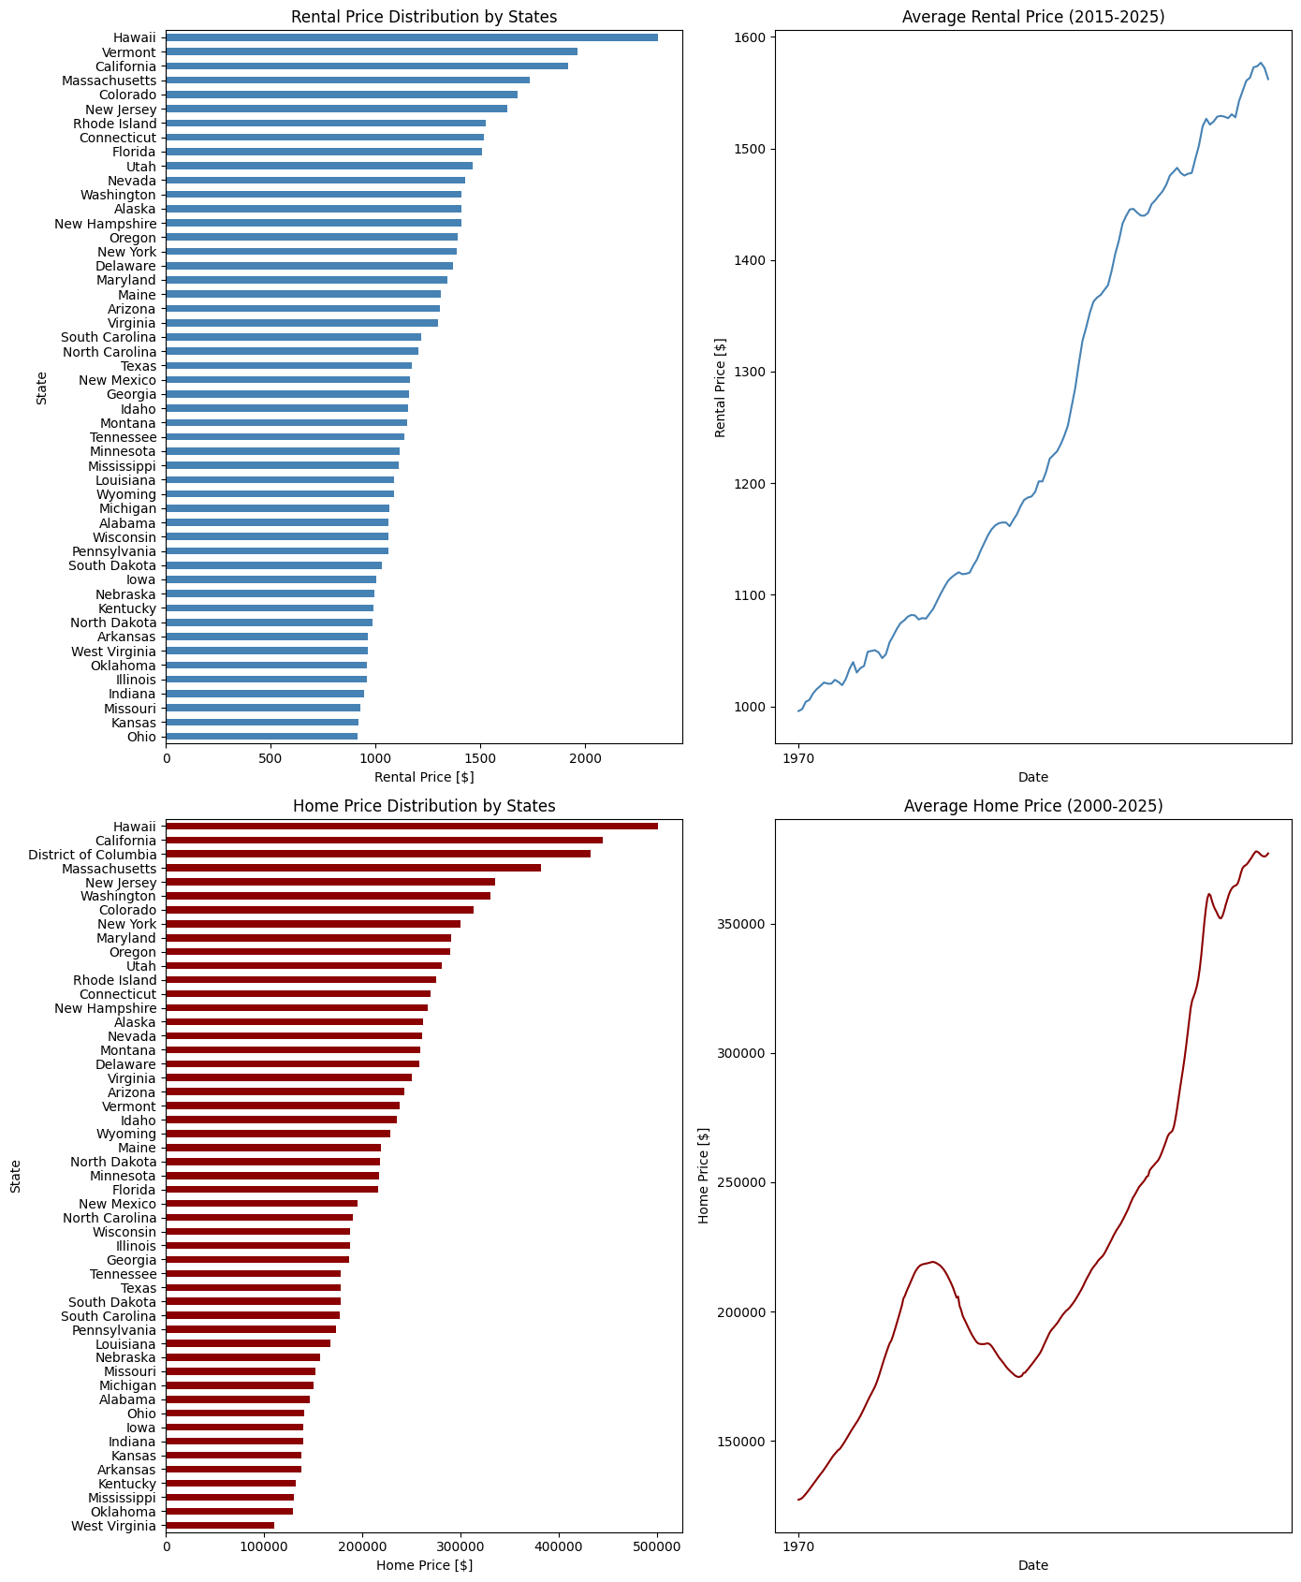
Figure 3.1: Distribution of Rental and Home Prices Across U.S. States (2015–2025)

To address non-stationarity and align with the causal question ("Does rent growth cause price growth?"), all level variables were transformed to 12-month growth rates:
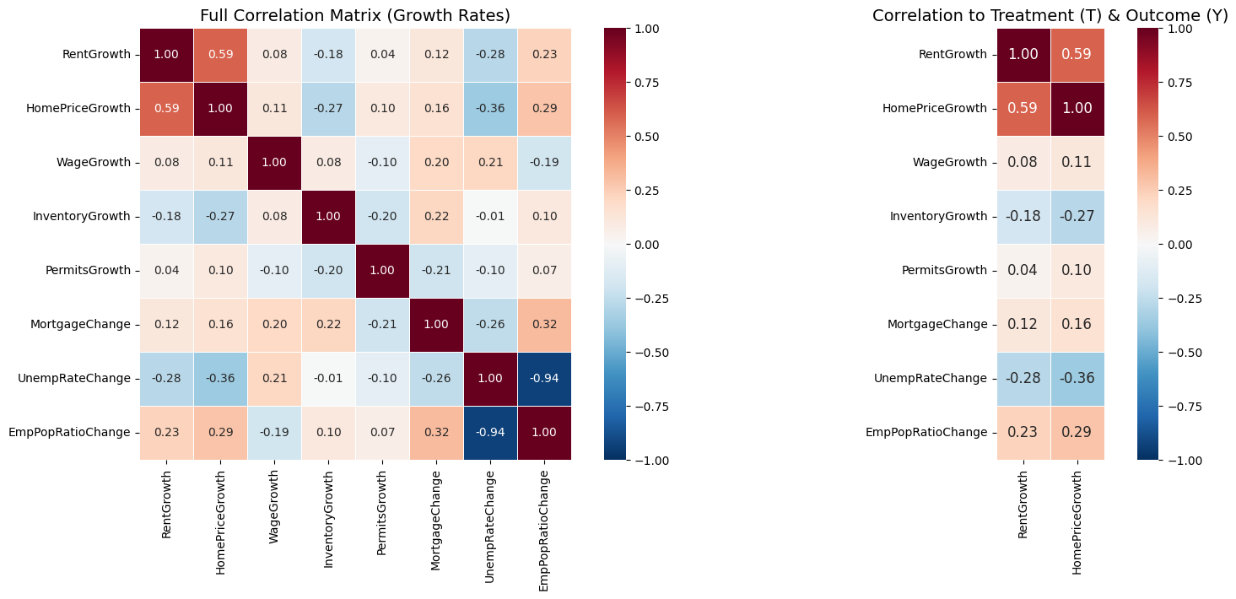
Figure 3.2: Correlation Matrix of Growth Rate Variables

This transformation reduced the Rent-HomePrice correlation from 0.89 (levels) to 0.59 (growth rates), removing false significant trend-driven correlation.

3.2.6 Lag Structure for Causal Identification
A temporal lag structure was implemented to establish causal ordering:
Variable Type | Timing | Description
Treatment (T) | t | RentGrowth — 12-month rent growth rate
Outcome (Y) | t + 12 | HomePriceGrowth_t12 — 12-month home price growth
Confounders (W) | t − 12 | All economic indicators lagged 12 months
Table 3.5: Temporal Lag Structure for Causal Identification
This structure ensures confounders are measured before treatment, treatment before outcome, and provides a 12-month horizon for rent changes to transmit to home prices.

3.2.7 Outliers
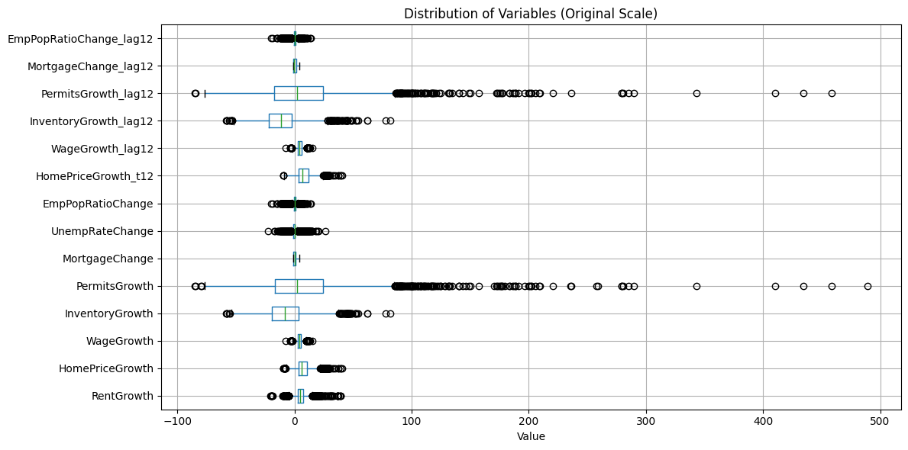
Figure 3.3: Distribution of Variables in Original Scale with Outliers
Although there are numerous outliers, the researchers chose to retain them because:
- They reflect real economic data variation (like the COVID-19 pandemic or just the overall natural rightly skewed data for some variables) and removing them might bias the causal effect estimate.
- The researchers ought to use Tree-Based models which are all robust to outliers since they partition on ranks instead of magnitude.

3.2.8 Encoding for Machine Learning
State fixed effects were encoded using two methods:
Method | Variables Created | Used For
One-hot encoding (drop_first=True) | 49 state dummies | DoubleML (linear confounders)
Label encoding | 1 StateCode variable | Causal Forest (tree splits)
Table 3.6: State Fixed Effects Encoding Methods

3.2.8 Final Analytical Dataset

Attribute | Value
Observations | 2,300 state-month pairs
Time Period | March 2020 – December 2023
Cross-sectional Units | 50 U.S. States
Treatment Variable | RentGrowth (1 variable)
Outcome Variable | HomePriceGrowth_t12 (1 variable)
Lagged Confounders | 5 variables
State Fixed Effects | 49 dummy variables
Total Features | 54 confounders
Table 3.7: Final Analytical Dataset Characteristics

3.3 Model Selection and Rationale
We employ Double Machine Learning (DoubleML) with Gradient Boosting base learners for estimating the Average Treatment Effect (ATE), and Causal Forest for heterogeneous treatment effects (CATE).
DoubleML was selected because it combines ML's predictive flexibility with valid causal inference through orthogonalization and cross-fitting, addressing regularization bias that would invalidate standard ML for causal estimation (Chernozhukov et al., 2018).
Gradient Boosting serves as the base learner due to its superior performance on our nuisance functions (R² = 0.643380 for outcome, 0.280706 for treatment prediction) compared to Random Forest and LightGBM.
Causal Forest (Wager & Athey, 2018) enables detection of heterogeneous effects across states and market conditions, revealing where rent-to-price transmission is strongest.

3.4 Experimental Setup

3.4.1 For Average Treatment Effect (ATE) Estimation:
Metrics:
- ATE coefficient
- Standard error
- 95% confidence intervals
- P-values for statistical significance.
Training and Testing Strategy:
- 5-fold cross-fitting as required by DoubleML to prevent overfitting bias.
Validation and Sensitivity Analysis:
- Negative Mean Squared Error of nuisance functions (as the standard practice)
- E-value for sensitivity to unmeasured confounding.
- Placebo Outcome Test for false causal effects.
- Specification checks test whether the conclusions are robust across different reasonable specifications:
  - Economic only - economic confounders like wage growth and employment to population ratio.
  - Housing only - inventory, permits, and mortgage
  - Economic+Housing - combination of economic and housing
  - States only - location specific
  - All confounder
Hyperparameter Tuning: Grid search over
- learning rate (0.05, 0.1),
- max depth (3-5),
- n_estimators (100-300)
- 5-fold CV
- optimizing nuisance function Negative Mean Squared Error.
3.4.2 For Conditional Average Treatment Effect (CATE) Estimation:
Metrics:
  - Individual treatment effects τ(x) for each observation
- 95% confidence intervals
- Feature importance for heterogeneity drivers
Training and Testing Strategy:
  - Honest splitting: separate samples for tree structure and leaf estimation to prevent overfitting
  - Out-of-bag (OOB) predictions for unbiased CATE estimates
Validation and Sensitivity Analysis:
  - R² score from RScorer to test whether heterogeneity is real vs noise (R² > 0 indicates meaningful heterogeneity)
  - Comparison of CATE mean to ATE estimate (should be approximately equal)
  - Overlap histogram to verify positivity assumption across treatment distribution
Hyperparameter Tuning: Grid search over
    - n_estimators (100-500)
    - max_depth (5-10)
    - min_samples_leaf (5-20)
    - Optimizing out-of-bag CATE variance

Chapter 4: Empirical Results and Model Analysis

4.1 Computational Environment and Experimental Implementation
All experiments were conducted using Python 3.10 on a standard computational environment. The analysis leveraged several specialized libraries for causal machine learning:
- EconML (Microsoft's Causal ML library) for Causal Forest implementation
- DoubleML for Double Machine Learning estimation following Chernozhukov et al. (2018)
- scikit-learn for base machine learning models (RandomForest, GradientBoosting)
- LightGBM for efficient gradient boosting implementation
- pandas, numpy, matplotlib, seaborn for data manipulation and visualization
The final analytical dataset comprised 2,300 state-month observations spanning March 2020 through December 2023, covering all 50 U.S. states. The feature space included 54 confounders: 5 lagged economic indicators, 49 state fixed effects (one-hot encoded with drop_first=True), and 3 year fixed effects. Cross-validation used 5-fold splitting as required by the DoubleML framework to prevent overfitting bias through the cross-fitting procedure.

4.2 Baseline Models
Before estimating the causal effect, an appropriate baseline model should be chosen. Three candidates, all which are tree-based model, undergone grid

4.2.1 Hyperparameter Tuning
Grid search with 5-fold cross-validation was conducted to optimize the Gradient Boosting hyperparameters. The search space included: learning rate (0.01, 0.05, 0.1), maximum depth (3, 5, 7, 10), number of estimators (100, 200, 300), minimum samples per leaf (1, 5, 10), and subsample ratio (0.8, 1.0). This resulted in 216 parameter combinations evaluated for each nuisance function (261 x 5 = 1080 fits per model).
The optimal parameters differed between the two nuisance functions, reflecting their distinct prediction challenges:
- Outcome Model (ml_g): learning_rate=0.1, max_depth=5, min_samples_leaf=5, n_estimators=300, subsample=0.8
- Treatment Model (ml_m): learning_rate=0.1, max_depth=3, min_samples_leaf=1, n_estimators=200, subsample=0.8
Configuration | R²(Y|W) | R²(T|W) | Avg R²
Untuned | 0.6434 | 0.2807 | 0.4620
Tuned | 0.6543 | 0.2936 | 0.4739
Improvement | +1.09% | +1.29% | +1.19%
Table 4.1: Impact of Hyperparameter Tuning on Nuisance Function Performance
Hyperparameter tuning yielded modest but consistent improvements across both nuisance functions, with the treatment model showing the largest relative gain (+1.29%). While these improvements are marginal, they contribute to more accurate residualization in the DoubleML procedure.

4.2 Primary Model Results: Average Treatment Effect
The Average Treatment Effect (ATE) was obtained using Double Machine Learning with the tuned Gradient Boosting models mentioned earlier. The DoubleML framework implements the Partially Linear Regression (PLR) model, which estimates the causal (constant scalar and linear) parameter θ in the structural equation together with the residuals in both baseline models:
Y = θT + g(W) + ε
where Y is HomePriceGrowth at t+12, T is RentGrowth at t, W represents all confounders (lagged economic indicators plus state and time fixed effects), and g(W) is a confounder effect g(X) can be arbitrarily complex (nonlinear) function estimated by machine learning (baseline model for confounders). The orthogonalization and cross-fitting procedures eliminate regularization bias while maintaining valid statistical inference.
The 3-step orthogonalization procedure:
- Estimate nuisance functions: ĝ(W) = E[Y|W] and m̂(W) = E[T|W].
- Compute residuals: Ỹ = Y - ĝ(W) and T̃ = T - m̂(W). This is essentially freeing treatment and outcome from the effects of the confounders.
- Estimate θ from residualized regression
Estimating equation:
Ỹ = θT̃ + ε
Essentially, in doubleML, outcome residual was regressed on the treatment residual after partialling out the confounders.

Parameter | Estimate | Std. Error | p-value | 95% CI
ATE (θ) | 0.0514 | 0.0132 | <0.001*** | [0.026, 0.085]
Table 4.2: Double Machine Learning Estimate of Average Treatment Effect
Note: *** p < 0.001. n = 2,300 state-month observations.
Interpretation: The estimated ATE of 0.0514 indicates that a 1 percentage point increase in annual rent growth causes a 0.0514 percentage point increase in home price growth 12 months later. This effect is statistically significant at the 0.1% level (p < 0.001), and the 95% confidence interval [0.026, 0.085] excludes zero, providing strong evidence of a causal relationship.
To contextualize, if median house price in a state is currently valued at $350,000, then if the annual rent growth in the same state increased by 10%, the causal effect would translate to 0.514 percentage points higher home price growth (10 × 0.0514)--which is about $1,799 in additional appreciation per home. Although modest at the individual property, the effect aggregates substantially across the whole state.

4.3.1 Sensitivity Analysis and Robustness Checks
Causal inference from observational data requires careful assessment of potential threats to validity and transgression of assumptions. The researcher conducted three complementary sensitivity analyses to evaluate the robustness of the ATE estimate.
E-Value Analyses. The E-value gives a point estimate for the minimum association effects an unmeasured confounder would need in order to eliminate the observed effect. The calculated E-value of 4.53 indicates that unmeasured confounders need to be associated with BOTH the rent growth and home price by a factor of 4.53 (on the risk ratio scale) or greater just to nullify the estimated ATE. For comparison, the strongest confounder is MortgageChange with joint association strength of only 1.50. This gap suggests that unmeasured confounding is unlikely to explain the observed causal relationship.
Placebo Outcome Test. The researcher conducted 50 iterations of the Placebo Outcome Test by randomly shuffling the treatment variable to simulate a random dataset to break any true causal relationship–to test if the ATE was truly present. Under the null hypothesis of no causal effect, the placebo ATE should center around zero. The mean placebo ATE was -0.0017 (effectively zero), confirming that the DoubleML procedure does not generate false causal effects when the treatment-outcome relationship is severed. This provides confidence that the estimated effect of 0.0514 reflects genuine causal transmission rather than methodological artifacts.
Specification Robustness. The researchers re-estimated the ATE under different combinations of confounders to assess whether the results depend critically on any particular set of control variables.

Specification | ATE Estimate | Significance
Full Model (baseline) | 0.0658 | ***
State Fixed Effects Only | 0.0951 | ***
Economic Confounders Only | 0.1749 | ***
Housing Confounders Only | 0.2721 | ***
Economic + Housing | 0.2524 | ***
Table 4.3: Specification Robustness Analysis
Note: *** p < 0.001
The ATE remains positive and highly significant among all specifications–howere, the point estimate varies. To be particular, the treatment effect is largest when only controlling for economic or housing but significantly jumps down when the state variables were included. This pattern shows the effect of location in moving both rent growth and home price growth, at least in the state-level. However, it is worth noting that as the confounders approach the full model, the ATE estimate decreases–this is what should happen since the confounders effect were being controlled. The full model's estimate of 0.0514-0.0658 represents the most conservative and likely the most accurate causal estimate.

4.3 Primary Model Results: Conditional Average Treatment Effect
DoubleML’s Average Treatment Effect or the average causal effect isn’t enough given that economic theory suggests that rent-to-price transmission should vary across different markets with different supply characteristics. Saiz (2010) documented that the state’s responsiveness to price signals by constructing new units (or housing supply elasticity) varies dramatically among each other–primarily due to geographical constraints. Markets with inelastic (lower elasticity) should exhibit stronger rent-to-price transmission because demand shocks cannot be responded to by constructing new houses.
To investigate this heterogeneity, the research estimated the Conditional Average Treatment Effects (CATEs) using Causal Forest by Wager and Athey (2018). The algorithm adopted random forest methodology but instead of looking for the best feature split to minimize the difference in loss function, the Causal Forest looks to maximize the difference in causal effect estimate between two child nodes. "Honest” sample splitting was used to avoid overfitting and infer valid confidence intervals: 50% of sample is to build tree structure or determine the splits and 50% is used to estimate the treatment effects in the leaves.
Statistic | Value
Mean CATE | 0.0508
Standard Deviation | 0.0506
Range | [-0.112, 0.218]
Interquartile Range (IQR) | 0.0562
Coefficient of Variation | 99.68%
Table 4.4: Causal Forest Results - Conditional Average Treatment Effect Distribution

4.4.1 Interpretation

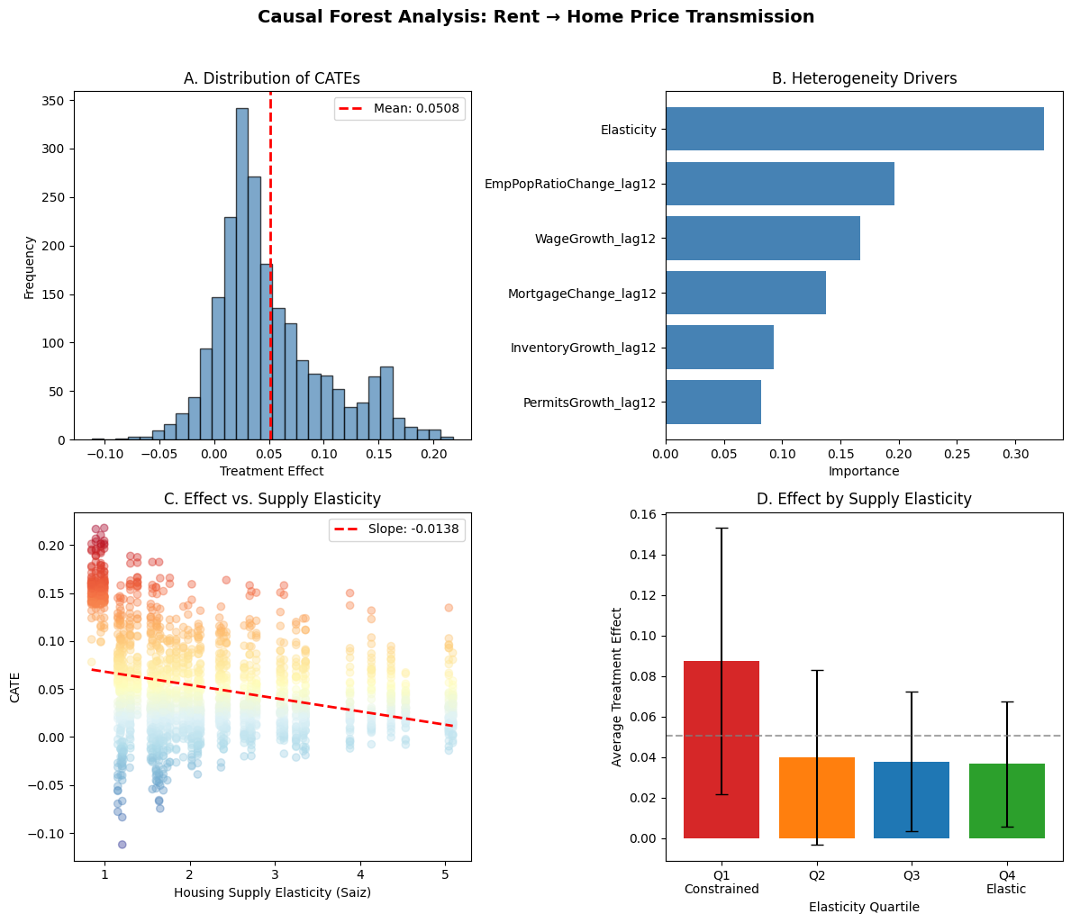
Figure 4.1: Causal Forest Analysis of Rent-to-Home Price Transmission
The Causal Forest analysis reveals a consistency between actual and theoretical heterogeneity in rent-to-price transmission.
ATE and CATE Validation. Panel A shows individual treatment effects ranging from -0.11 to +0.22, with the mean (0.0508) to validate the DoubleML estimate–mean CATE (0.0508) closely matches the DoubleML ATE estimate (0.0514).
Feature Importance. Panel B identifies housing supply elasticity as the dominant driver of this heterogeneity (32.5% importance).

Effect Modifier | Importance | Rank
Housing Supply Elasticity (Saiz) | 0.3246 | 1
Employment-Population Ratio Change | 0.1965 | 2
Wage Growth | 0.1671 | 3
Mortgage Rate Change | 0.1374 | 4
Inventory Growth | 0.0926 | 5
Building Permits Growth | 0.0817 | 6

Table 4.5: Causal Forest Feature Importance for Treatment Effect Heterogeneity
This finding validates Saiz (2010) that supply-constrained markets are systematically different from elastic markets (heterogeneity).
Employment dynamics (employment-population ratio change) and wage growth collectively account for an additional 36% of heterogeneity, suggesting that labor market conditions moderate how rental market signals translate to home prices. Financial conditions (mortgage rates) and supply pipeline indicators (inventory, permits) contribute the remaining variation.
Gradual Descent of Treatment Effects. Panels C and D confirm the theoretical prediction from Saiz (2010): supply-constrained markets (Q1) exhibit treatment effects 2.4 times larger than elastic markets (Q4), with a consistent negative slope of -0.0138 between elasticity and effect size.

Elasticity Quartile | Mean CATE | Std. Dev.
Q1 (Most Constrained) | 0.0874 | 0.0657
Q2 | 0.0399 | 0.0431
Q3 | 0.0378 | 0.0345
Q4 (Most Elastic) | 0.0368 | 0.0309
Table 4.6: Average Treatment Effect by Housing Supply Elasticity Quartile
This finding has direct policy implications such that the rental market interventions will have the greatest downstream impact on homeownership affordability in supply-constrained states like California and New York.
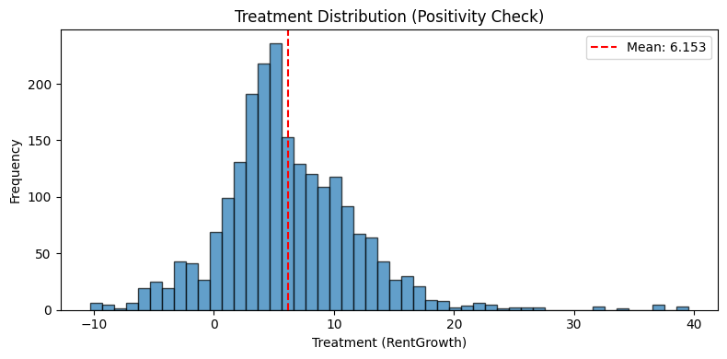
Figure 4.2: Treatment Distribution for Positivity Assumption Verification
Some state-periods exhibit negative effects (rent increases associated with subsequent price decreases), while others show effects more than four times the average. Treatment values span from -10.3% to +39.5% with standard deviation of 5.70, indicating sufficient variation across the treatment distribution.

4.4 Dashboard
An AI-Generated dashboard was procured to showcase both the result and the utility of the model.This isn’t the main point of the study but it’s worth showcasing such capability of the model to demonstrate how it could be utilized in the future.

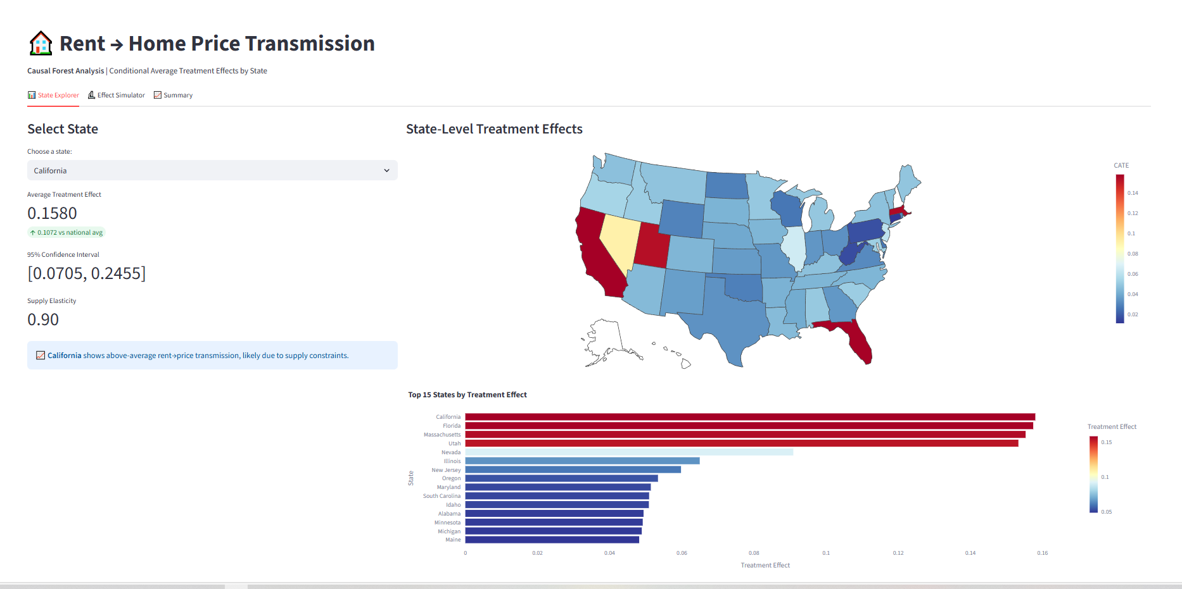 | 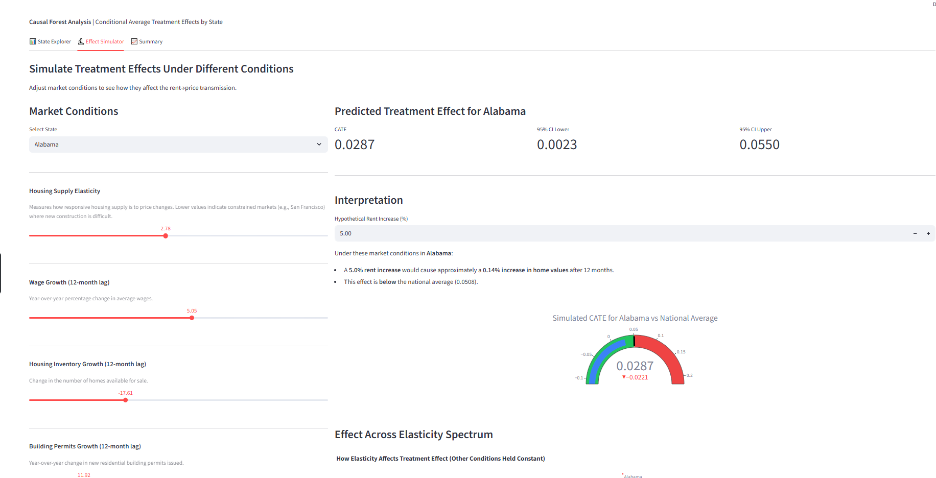
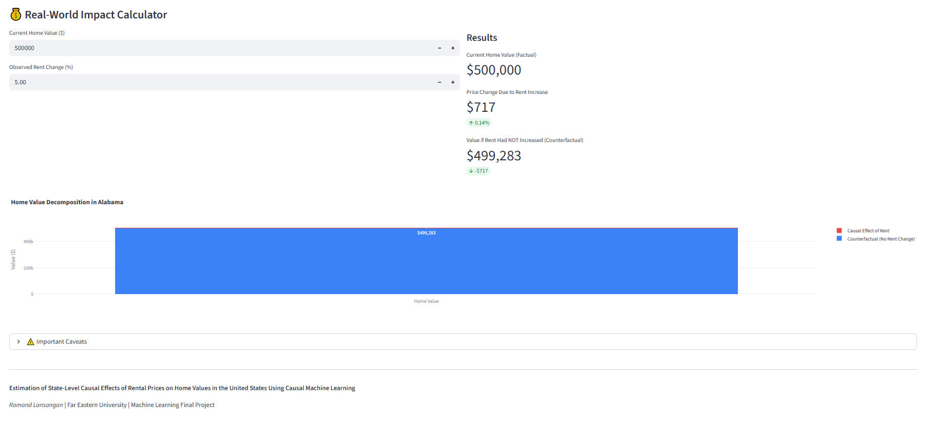 | 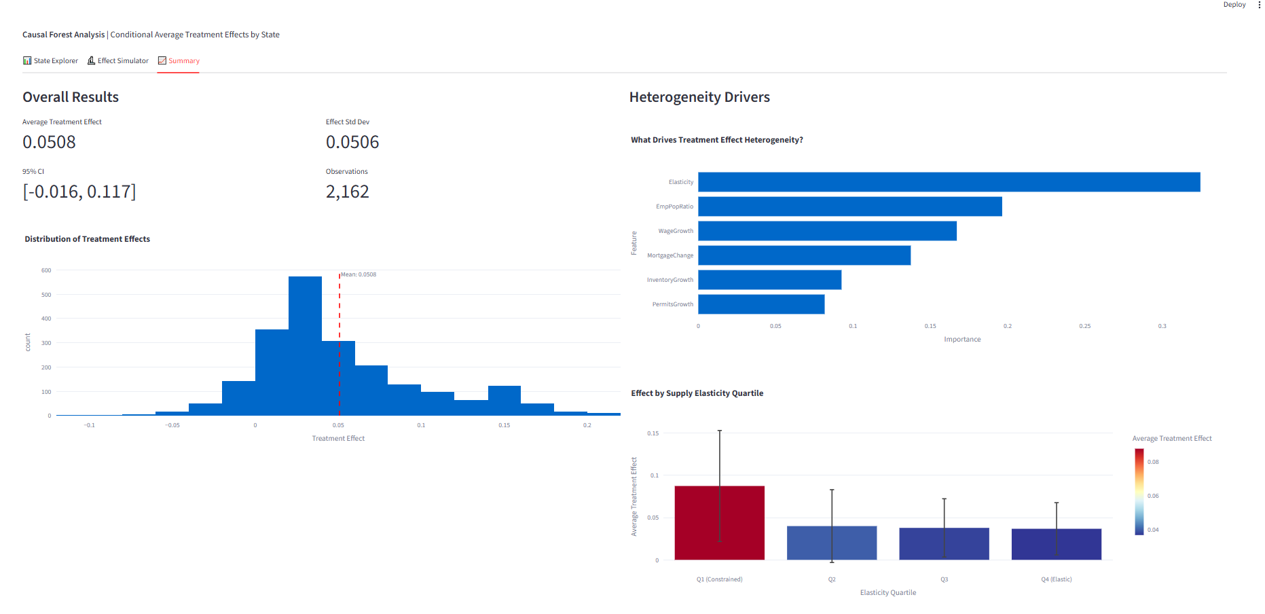

Figure 4.3: Interactive Dashboard for Exploring State-Level Treatment Effects
The repository could be accessed here together with the necessary resources like the dataset and the virtual environment for dependencies.
https://github.com/RomandRapido/Rent-Price-Causal-Analysis-Dashboard/tree/main

4.5 Discussion of Results
The empirical analysis provides insightful and robust evidence to support the causal relationship between annual rental price growth and the home price growth a year later. Several key findings emerged from the analysis that directly addressed the core questions of this research:
First, rent causally affects home prices. The DoubleML estimate of θ = 0.0514 (p < 0.001) indicates that a 1 percentage point increase in annual rent growth causes approximately 0.05 percentage points higher home price growth 12 months later. This effect is economically meaningful: when there are periods of rapid rent growth (10+ percentage points annually), the cumulative effect on home prices would also be substantial. The 95% confidence interval [0.026, 0.085] excludes zero, and the E-value of 4.53 suggests the result is robust to the assumption of unconfoundedness.
Second, the causal effect is heterogeneous. Causal Forest analysis reveals a significant difference, heterogeneity, of treatments effects across markets. The most dominant modifier is the supply elasticity with 32.5% importance validating the theoretical prediction of Saiz (2010)--while also providing actionable geographically targeted information that could be proven useful for policy making. Additionally, supply-constrained markets exhibit rent-to-price transmission effects more than twice as large as elastic markets (0.087 vs. 0.037).
Third, the results are robust to alternative specifications. The causal effect remains positive and highly significant across all specification robustness checks, placebo tests confirm the methodology does not generate spurious effects, and the CATE mean closely matches the ATE estimate from an independent method.
Theoretical Interpretation. The findings are consistent with the present-value framework for housing prices (Campbell & Shiller, 1988; Campbell et al., 2009). Under this framework, home prices reflect discounted expected future rents. When current rents increase, buyers rationally update expectations about future rental income streams, leading to higher prices they are willing to pay. The Gordon Growth Model specifically predicts P = R/(r-g), where higher rent growth expectations (g) increase prices (P).
The supply elasticity heterogeneity also has a clear theoretical interpretation. In markets with elastic housing supply, demand shocks (reflected in rent increases) can be partially accommodated through new construction, dampening price effects. The same cannot be said on the supply-contrained (or inelastic) markets. This mechanism explains why California (elasticity ≈ 0.9) and similar markets experience amplified rent-to-price transmission compared to Texas (elasticity ≈ 2.5).
4.6 Limitations
Several limitations warrant acknowledgment:
- The period over which the researchers studied the market, from 2020 to 2023, coincided with the COVID-19 pandemic. This ensued unusual dynamics such as remote work and supply chain issues, whose presence affects how accurately this model can be applied pre-pandemic.
- Additionally, aggregating by state can conceal regional heterogeneity, particularly in larger states.
- Another is that the researchers took advantage of a twelve-month lag in between treatment and outcome measurement in order to show causality. However, any twelve-month has its own arbitrary nature and not all markets have the same transmission speeds.
Despite these limitations, the analysis provides the first rigorous causal estimate of rent-to-price transmission using modern machine learning methods, with explicit attention to heterogeneity across market types. The findings have direct implications for housing policy, investment strategy, and macroeconomic modeling, as discussed in Chapter 5.

Chapter 5: Conclusion and Future Work

5.1 Summary of Findings
This research was able to successfully quantify the causal effect of rental price growth on future (12 months later) home price growth using Double Machine Learning and Causal Forest. The DoubleML analysis produced a statistically significant Average Treatment Effect with θ = 0.0513 (p < 0.001, 95% CI: [0.026, 0.085]), which implies that a 1 percentage point increase in rent growth will cause 0.05 percentage points of increase in home prices 12 months later. Robustness checks like E-value of 4.53, placebo outcome tests with 50 iterations, and specification analysis; confirm the validity of these estimates. Causal Forest, on the other hand, revealed a significant heterogeneity. In line with Saiz (2010), inelastic or supply-constrained markets exhibits 2.4 times stronger rent-to-price transmission than elastic markets (CATE: 0.087 vs 0.037), housing supply then became the most important effect modifier that define the effect transmission mechanism of treatment to outcome (32.5% feature importance).

5.2 Project Contribution and Significance
This research provides
- The first rigorous/empirical causal estimate of rent-to-price transmission through orthogonalization.
- Thus the evidence of geographic heterogeneity and actionable insights on where to develop relevant policy like rental controls and support–in such a way that they will have the most impact.
- The results also validates the theoretical predictions of Campbell & Shiller (1988) and Saiz (2010) to confirm that buyers rationally updates that price they are willing to pay based on rental income expectations that ought to be amplified by housing supply elasticity on the particular location.

5.2 Project Contribution and Significance
Key limitations include:
- 2020-2023 overlaps with COVID-19’s atypical market dynamics–questioning the model’s generalizability.
- State-level aggregation may mask some granular market dynamics, especially of those larger markets.
- The unconfoundedness cannot be directly tested though robustness checks were conducted.

5.3 Recommendations for Future Work
MSA-Level Geographic Scope. Future work should leverage Zillow’s metro level data and find the appropriate confounders to match such spatial granularity. MSA-Level analysis would capture within-state dynamics (possible heterogeneity) and enable a more targeted policy.
Extended Date Range. Incorporating pre-pandemic data (2015-2019), would enable future researchers to examine market dynamics and its effects on different period: 2015-2019 being the more stable one, 2020-2022 the outlier/shock, and the 2023 beyond to be the recovery.
Production Pipeline. Deploying an automated data pipeline with streaming integration would enable continuous model updates and real-time monitoring on the market dynamics (specifically rent-to-price transmission)--which further supports policy responses and investment decisions. Given the data sources, most, if not all of them could be attained through API so the feasibility is not questionable either.
Different Set of Confounders. Future researchers can expand to other variables like demographics, policy indicators, or more financial metrics to strengthen the validity for unconfoundedness assumption of causal analysis.
Alternative Treatments. Future researchers could leverage the framework introduced by this study to learn more about factors that affect home pricing and affordability–which would be proven useful for home is after all, a basic necessity.

REFERENCES
Batzer, R. M., Coste, J. R., Doerner, W. M., & Seiler, M. J. (2024). The lock-in effect of rising mortgage rates. Federal Housing Finance Agency Working Paper 24-03.
Campbell, J. Y., & Shiller, R. J. (1988). Stock prices, earnings, and expected dividends. Journal of Finance, 43(3), 661-676.
Campbell, S. D., Davis, M. A., Gallin, J., & Martin, R. F. (2009). What moves housing markets: A variance decomposition of the rent-price ratio. Journal of Urban Economics, 66(2), 90-102.
Chernozhukov, V., Chetverikov, D., Demirer, M., Duflo, E., Hansen, C., Newey, W., & Robins, J. (2018). Double/debiased machine learning for treatment and structural parameters. The Econometrics Journal, 21(1), C1-C68.
Gallin, J. (2008). The long-run relationship between house prices and rents. Real Estate Economics, 36(4), 635-658.
Harvard Joint Center for Housing Studies. (2025). The state of the nation's housing 2025. Harvard University.
National Association of Home Builders. (2024). Housing affordability pyramid. NAHB Economics and Housing Policy Group.
Pearl, J. (2009). Causality: Models, reasoning, and inference (2nd ed.). Cambridge University Press.
Rubin, D. B. (1974). Estimating causal effects of treatments in randomized and nonrandomized studies. Journal of Educational Psychology, 66(5), 688-701.
Saiz, A. (2010). The geographic determinants of housing supply. The Quarterly Journal of Economics, 125(3), 1253-1296.
Wager, S., & Athey, S. (2018). Estimation and inference of heterogeneous treatment effects using random forests. Journal of the American Statistical Association, 113(523), 1228-1242.
OECD. (2024). The Philippines. In Addressing legal and regulatory barriers to quality infrastructure investment in India, Indonesia and the Philippines. OECD Publishing. https://www.oecd.org/en/publications/addressing-legal-and-regulatory-barriers-to-quality-infrastructure-investment-in-india-indonesia-and-the-philippines_fb81e1be-en/full-report/the-philippines_92bd12d8.html
Philippine Institute for Development Studies. (2025, January 16). Infrastructure investments need a comprehensive database – PIDS. In the News. PIDS - Philippine Institute for Development Studies
Potin, L., Figueiredo, R., Labatut, V., & Largeron, C. (2023). Pattern mining for anomaly detection in graphs: Application to fraud in public procurement. arXiv. https://arxiv.org/abs/2306.10857
Ramos, M. (2025, September 30). How flood control projects fail the poor in the Philippines. Context. https://www.context.news/climate-risks/how-flood-control-projects-fail-the-poor-in-the-philippines
Resimić, M. (2025). Harnessing artificial intelligence (AI) for anti-corruption [U4 Helpdesk Answer]. Transparency International & U4 Anti-Corruption Resource Centre. https://knowledgehub.transparency.org/assets/uploads/kproducts/Harnessing-artificial-intelligence-for-anti-corruption_01.10.2025.pdf
Schneider dos Santos, E., Santos, M. M., Castro, M., & Carvalho, J. T. (2025). Detection of fraud in public procurement using data-driven methods: A systematic mapping study. EPJ Data Science, 14(1), Article 52. SpringerLink+2doaj.org+2
World Bank. (2021). Climate risk country profile: Philippines. https://climateknowledgeportal.worldbank.org/sites/default/files/country-profiles/15852-WB_Philippines%20Country%20Profile-WEB.pdf
Yet, B. (2016). A Bayesian network framework for project cost, benefit and risk analysis with an agricultural development case study. Expert Systems with Applications, 60, 141–155.

Appendix A: Code Snippets

A.1 Data Sources and Initial Processing

B.1 Bureau of Labor Statistics (BLS) Employment Data
Source: https://data.bls.gov/multi-screen?survey=la
Variables: unemployment rate, employment, labor force, employment-population ratio
Scale: Monthly, State-level (2000–2024)
import pandas as pd
df = pd.read_html('employment_data.html')
final_df = pd.DataFrame()
current_state, current_metric = "", ""
for i in range(len(df)):
if i % 2 != 0:
temp_df = df[i].copy()
temp_df['State'] = current_state
temp_df['Metric'] = current_metric
final_df = pd.concat([final_df, temp_df], ignore_index=True)
else:
current_state = df[i].iloc[4, 1]
current_metric = df[i].iloc[5, 1]
months = final_df.columns[3:].tolist()
df_melted = final_df.melt(id_vars=['State', 'Metric', 'Year'], value_vars=months,
var_name='Month', value_name='Value')
df_cleaned = pd.pivot_table(df_melted, index=['State', 'Year', 'Month'],
columns='Metric', values='Value').reset_index()

A.2 FRED 30-Year Mortgage Rate
Source: https://fred.stlouisfed.org/series/MORTGAGE30US
Scale: Weekly (1971–2025), aggregated to monthly

df = pd.read_csv('MORTGAGE30US.csv')

A.3 FRED Average Hourly Earnings by State
Source: https://fred.stlouisfed.org/tags/series?t=earnings%3Bemployment%3Bmonthly%3Bprivate%3Bstate
Scale: Monthly, State-level (2007–2025)
import re
f = open("data_raw/Hourly_wage_by_States/README.txt")
f_str = f.read()
ids = re.findall(r'SMU.{17}', f_str)
states = [re.findall(r'in\s+(.+?)\s+20', row)[0].strip()
for row in f_str.split("\n") if "Total Private" in row]
df = pd.read_csv("data_raw/Hourly_wage_by_States/monthly.csv")
state_mapping = dict(zip(ids, states))
df_renamed = df.rename(columns=state_mapping)
df_cleaned = df_renamed.melt(id_vars=['observation_date'], value_vars=states,
var_name='State', value_name='Avg. Monthly Wage per Hours')

A.4 FRED Building Permits by State
Source: https://fred.stlouisfed.org/release?rid=118
Scale: Monthly, State-level (2000–2025)
import pandas_datareader as pdr
STATE_CODES = ['AL', 'AK', 'AZ', 'AR', 'CA', 'CO', 'CT', 'DE', 'FL', 'GA',
'HI', 'ID', 'IL', 'IN', 'IA', 'KS', 'KY', 'LA', 'ME', 'MD',
'MA', 'MI', 'MN', 'MS', 'MO', 'MT', 'NE', 'NV', 'NH', 'NJ',
'NM', 'NY', 'NC', 'ND', 'OH', 'OK', 'OR', 'PA', 'RI', 'SC',
'SD', 'TN', 'TX', 'UT', 'VT', 'VA', 'WA', 'WV', 'WI', 'WY', 'DC']
all_permits = {}
for state in STATE_CODES:
series_id = f"{state}BPPRIVSA"
df = pdr.DataReader(series_id, 'fred', '2000-01-01', '2025-12-31')
all_permits[state] = df[series_id]
permits_df = pd.DataFrame(all_permits)

A.5 Bureau of Economic Analysis (BEA) Regional Data
Source: https://apps.bea.gov/api/
Variables: Regional Price Parities, Personal Income, Population, Per Capita Income, PCE
Scale: Annual, State-level (2000–2024)
import requests
API_KEY = "YOUR_API_KEY"
BASE_URL = "https://apps.bea.gov/api/data/"
def fetch_bea_data(table_name, line_code, year="2000,2001,...,2024"):
params = {
"UserID": API_KEY, "method": "GetData", "datasetname": "Regional",
"TableName": table_name, "LineCode": str(line_code),
"GeoFips": "STATE", "Year": year, "ResultFormat": "JSON"
}
response = requests.get(BASE_URL, params=params)
return pd.DataFrame(response.json()["BEAAPI"]["Results"]["Data"])
datasets = [
{"name": "rpp_all_items", "table": "SARPP", "line_code": 1},
{"name": "rpp_goods", "table": "SARPP", "line_code": 2},
{"name": "rpp_services_rent", "table": "SARPP", "line_code": 3},
{"name": "personal_income", "table": "SAINC1", "line_code": 1},
{"name": "population", "table": "SAINC1", "line_code": 2},
{"name": "per_capita_income", "table": "SAINC1", "line_code": 3},
{"name": "pce_total", "table": "SAPCE1", "line_code": 1},
{"name": "pce_housing", "table": "SAPCE1", "line_code": 9},
]
all_data = {ds["name"]: fetch_bea_data(ds["table"], ds["line_code"]) for ds in datasets}

A.2 Data Paths Object
class DataPaths:
"""Central registry of all data file paths"""

def __init__(self, base_path="data_cleaned"):
self.BASE = Path(base_path)

# Bea
self.BEA_PANEL = self.BASE / "Bea" / "bea_panel_data.csv"
self.BEA_PCE_HOUSING = self.BASE / "Bea" / "bea_pce_housing.csv"
self.BEA_PCE_TOTAL = self.BASE / "Bea" / "bea_pce_total.csv"
self.BEA_PER_CAPITA_INCOME = self.BASE / "Bea" / "bea_per_capita_income.csv"
self.BEA_PERSONAL_INCOME = self.BASE / "Bea" / "bea_personal_income.csv"
self.BEA_POPULATION = self.BASE / "Bea" / "bea_population.csv"
self.BEA_RPP_ALL = self.BASE / "Bea" / "bea_rpp_all_items.csv"
self.BEA_RPP_GOODS = self.BASE / "Bea" / "bea_rpp_goods.csv"
self.BEA_RPP_SERVICES_RENT = self.BASE / "Bea" / "bea_rpp_services_rent.csv"

# Fred
self.FRED_PERMITS_LONG = self.BASE / "Fred" / "building_permits_long.csv"
self.FRED_PERMITS_WIDE = self.BASE / "Fred" / "building_permits_wide.csv"
self.FRED_POPULATION = self.BASE / "Fred" / "cleaned_anual_population.csv"
self.FRED_EARNINGS = self.BASE / "Fred" / "cleaned_monthly_earnings_by_hour.csv"
self.FRED_MORTGAGE = self.BASE / "Fred" / "MORTGAGE30US.csv"

# BLS
self.BLS_EMPLOYMENT = self.BASE / "BLS" / "cleaned_employment_data.csv"

# Zillow
self.ZILLOW_RENT_METRO = self.BASE / "Zillow" / "Metro_zori_uc_sfrcondomfr_sm_month.csv"
self.ZILLOW_PRICE_STATE = self.BASE / "Zillow" / "State_zhvi_uc_sfrcondo_tier_0.33_0.67_sm_sa_month.csv"
self.ZILLOW_INVENTORY_METRO = self.BASE / "Zillow" / "Metro_invt_fs_uc_sfrcondo_sm_month.csv"

# Others
self.OTHERS_SAIZ_ELASTICITY = self.BASE / "Others" / "saiz_elasticity.csv"

def list_all(self):
"""List all defined paths and whether they exist"""
for name, value in vars(self).items():
if isinstance(value, Path) and name != 'BASE':
exists = "✅" if value.exists() else "❌"
print(f"{exists} {name}: {value}")

def list_missing(self):
"""List only missing files"""
missing = []
for name, value in vars(self).items():
if isinstance(value, Path) and name != 'BASE':
if not value.exists():
missing.append((name, value))
print(f"❌ {name}: {value}")
return missing

def list_available(self):
"""List only available files"""
available = []
for name, value in vars(self).items():
if isinstance(value, Path) and name != 'BASE':
if value.exists():
available.append((name, value))
print(f"✅ {name}: {value}")
return available

data = DataPaths("../Data Collection/data_cleaned")
data.list_all()

A.3 Save Model and Resources for Dashboard
import joblib
import pandas as pd
import numpy as np
import os

BASE = "../Dashboard"

os.makedirs(os.path.join(BASE, "Model"), exist_ok=True)
os.makedirs(os.path.join(BASE, "Resources"), exist_ok=True)

# 1. Save the fitted Causal Forest model
joblib.dump(cf, os.path.join(BASE, "Model", "causal_forest_model.joblib"))

# 2. Create and save results DataFrame (X now has 6 features, no StateCode)
results_df = pd.DataFrame({
'StateFullName': state_clean.values, # Add this!
'elasticity': X_clean[:, 0],
'wage_growth': X_clean[:, 1],
'inventory_growth': X_clean[:, 2],
'permits_growth': X_clean[:, 3],
'mortgage_change': X_clean[:, 4],
'emp_pop_ratio': X_clean[:, 5],
'treatment': T_clean,
'outcome': Y_clean,
'cate': cate.flatten()
})

# Add confidence intervals
te_lower, te_upper = cf.effect_interval(X_clean, alpha=0.05)
results_df['cate_lower'] = te_lower.flatten()
results_df['cate_upper'] = te_upper.flatten()

results_df.to_csv(os.path.join(BASE, "Resources", "causal_forest_results.csv"), index=False)

# 3. Save state mapping (if still needed for reference)
state_mapping = df_cate[['StateFullName']].drop_duplicates().reset_index(drop=True)
state_mapping.to_csv(os.path.join(BASE, "Resources", "state_mapping.csv"), index=False)

# 4. Save feature importance (6 features now)
importance_df = pd.DataFrame({
'feature': ['Elasticity', 'WageGrowth', 'InventoryGrowth',
'PermitsGrowth', 'MortgageChange', 'EmpPopRatio'],
'importance': cf.feature_importances_
})
importance_df.to_csv(os.path.join(BASE, "Resources", "feature_importance.csv"), index=False)

# 5. Save summary statistics
summary_stats = {
'ate': float(cate.mean()),
'ate_std': float(cate.std()),
'ate_lower': float(te_lower.mean()),
'ate_upper': float(te_upper.mean()),
'n_obs': len(cate)
}
joblib.dump(summary_stats, os.path.join(BASE, "Resources", "summary_stats.joblib"))

state_abbrev = {
'Alabama': 'AL', 'Alaska': 'AK', 'Arizona': 'AZ', 'Arkansas': 'AR',
'California': 'CA', 'Colorado': 'CO', 'Connecticut': 'CT', 'Delaware': 'DE',
'Florida': 'FL', 'Georgia': 'GA', 'Hawaii': 'HI', 'Idaho': 'ID',
'Illinois': 'IL', 'Indiana': 'IN', 'Iowa': 'IA', 'Kansas': 'KS',
'Kentucky': 'KY', 'Louisiana': 'LA', 'Maine': 'ME', 'Maryland': 'MD',
'Massachusetts': 'MA', 'Michigan': 'MI', 'Minnesota': 'MN', 'Mississippi': 'MS',
'Missouri': 'MO', 'Montana': 'MT', 'Nebraska': 'NE', 'Nevada': 'NV',
'New Hampshire': 'NH', 'New Jersey': 'NJ', 'New Mexico': 'NM', 'New York': 'NY',
'North Carolina': 'NC', 'North Dakota': 'ND', 'Ohio': 'OH', 'Oklahoma': 'OK',
'Oregon': 'OR', 'Pennsylvania': 'PA', 'Rhode Island': 'RI', 'South Carolina': 'SC',
'South Dakota': 'SD', 'Tennessee': 'TN', 'Texas': 'TX', 'Utah': 'UT',
'Vermont': 'VT', 'Virginia': 'VA', 'Washington': 'WA', 'West Virginia': 'WV',
'Wisconsin': 'WI', 'Wyoming': 'WY', 'District of Columbia': 'DC'
}

# Load and update state mapping
# state_mapping.to_csv(os.path.join(BASE, "Resources", "state_mapping.csv"), index=False)

state_mapping = pd.read_csv(os.path.join(BASE, "Resources", "state_mapping.csv"))
state_mapping['StateAbbrev'] = state_mapping['StateFullName'].map(state_abbrev)
state_mapping.to_csv(os.path.join(BASE, "Resources", "state_mapping.csv"), index=False)

Appendix B: Data Dictionary
Title | Purpose in Project | Temporal Scale | Spatial Scale | Source
ZILLOW_RENT_METRO (ZORI) | Treatment variable – rental price index | Monthly (2015–2025) | Metro | Zillow
ZILLOW_PRICE_STATE (ZHVI) | Outcome variable – home value index | Monthly | State | Zillow
ZILLOW_INVENTORY_METRO | Confounder – housing supply availability | Monthly | Metro | Zillow
BEA_PERSONAL_INCOME | Confounder – purchasing power/demand | Annual | State | Bureau of Economic Analysis
BEA_PER_CAPITA_INCOME | Confounder – income normalized by population | Annual | State | Bureau of Economic Analysis
BEA_PCE_HOUSING | Confounder – housing expenditure patterns | Annual | State | Bureau of Economic Analysis
BEA_PCE_TOTAL | Confounder – total consumption expenditure | Annual | State | Bureau of Economic Analysis
BEA_POPULATION | Confounder – demographic pressure | Annual | State | Bureau of Economic Analysis
BEA_RPP_ALL | Confounder – regional price levels | Annual | State | Bureau of Economic Analysis
BEA_RPP_GOODS | Confounder – goods price levels | Annual | State | Bureau of Economic Analysis
BEA_RPP_SERVICES_RENT | Confounder – service/rent price levels | Annual | State | Bureau of Economic Analysis
BEA_PANEL | Combined BEA metrics | Annual | State | Bureau of Economic Analysis
FRED_PERMITS | Confounder – new housing supply pipeline | Monthly | State | Federal Reserve (FRED)
FRED_EARNINGS | Confounder – labor market / wage pressure | Monthly | State | Federal Reserve (FRED)
FRED_MORTGAGE | Confounder – financing costs | Monthly | National | Federal Reserve (FRED)
FRED_POPULATION | Confounder – demographic pressure | Annual | State | Federal Reserve (FRED)
BLS_EMPLOYMENT | Confounder – labor market conditions (unemployment, labor force participation) | Monthly (2000–2024) | State | Bureau of Labor Statistics
SAIZ_ELASTICITY | Effect modifier – housing supply constraints for CATE analysis | Static (time-invariant) | MSA | Saiz (2010)
Table B.1: Original Data Sources Metadata

Appendix C: Supplemental Figures/Tables
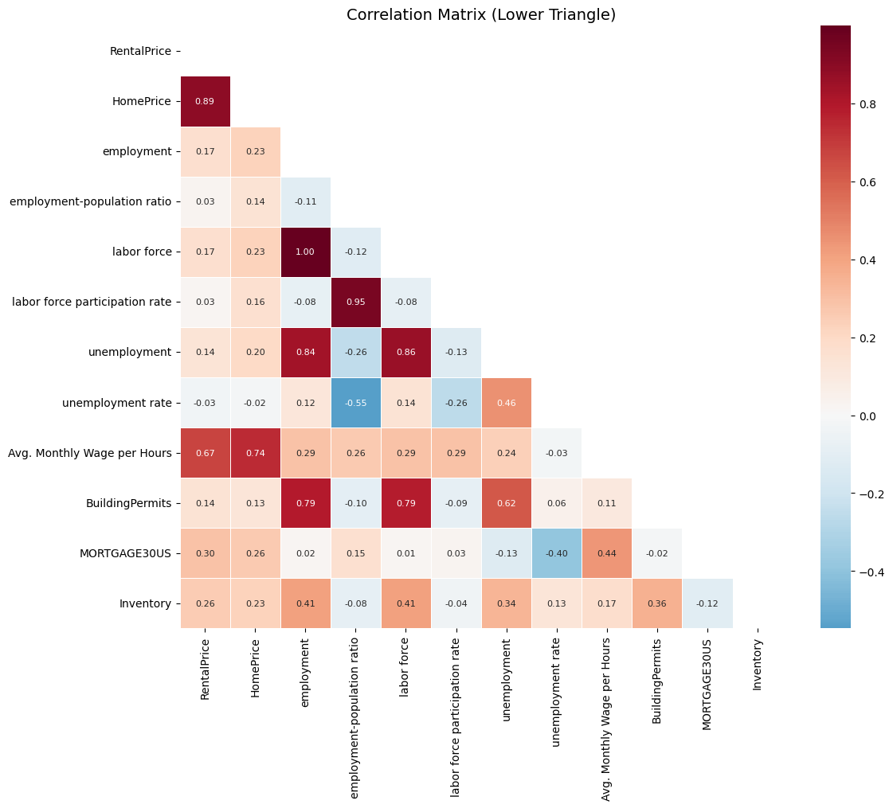
Figure C.1: Correlation Matrix of Level Variables (Pre-Transformation)

